Python and Bash Assignment submission to TUTEDUDE for DevOps Course.
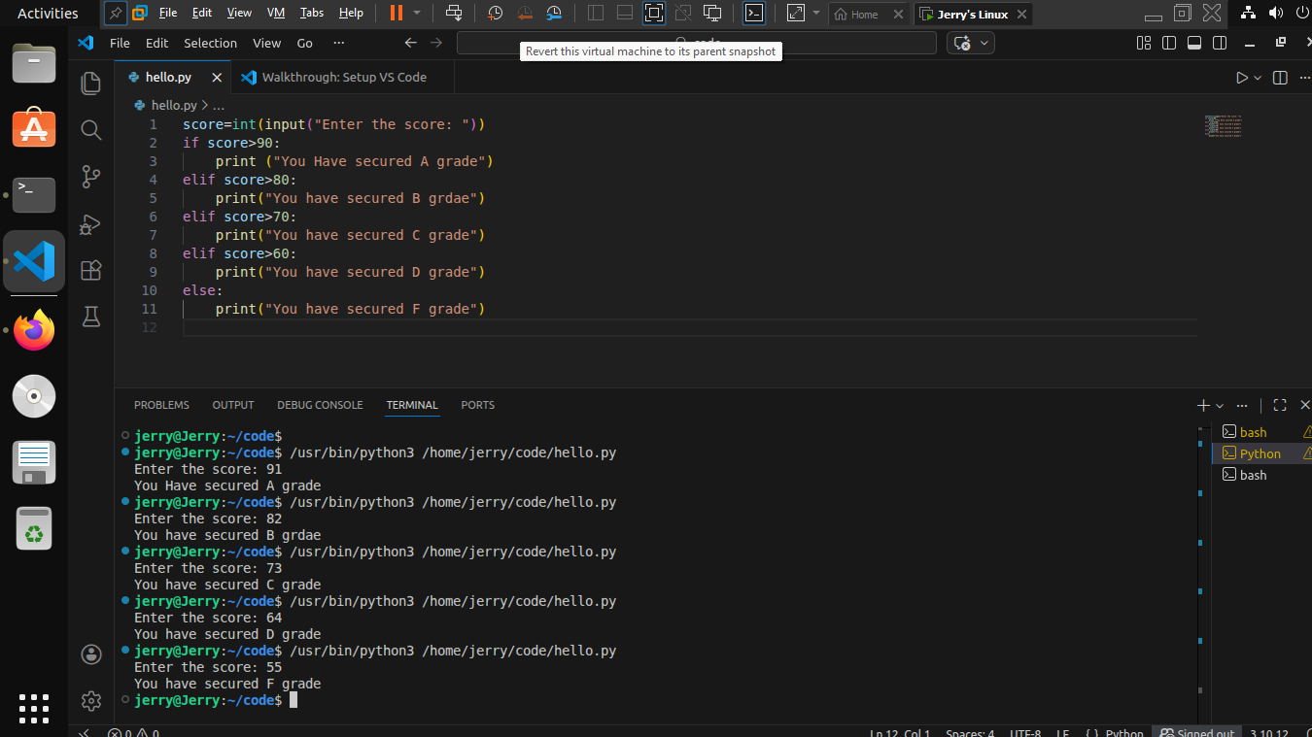
Figure 1 Grade Checker

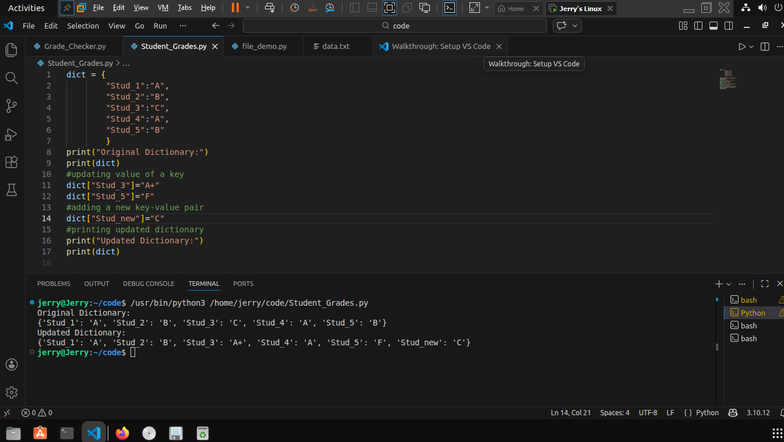
Figure 2 Student Grades
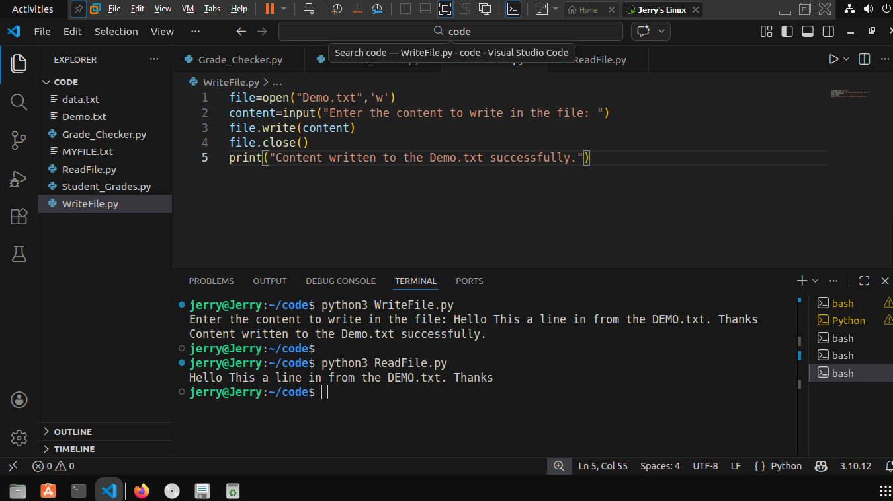
Figure 3Write to a File

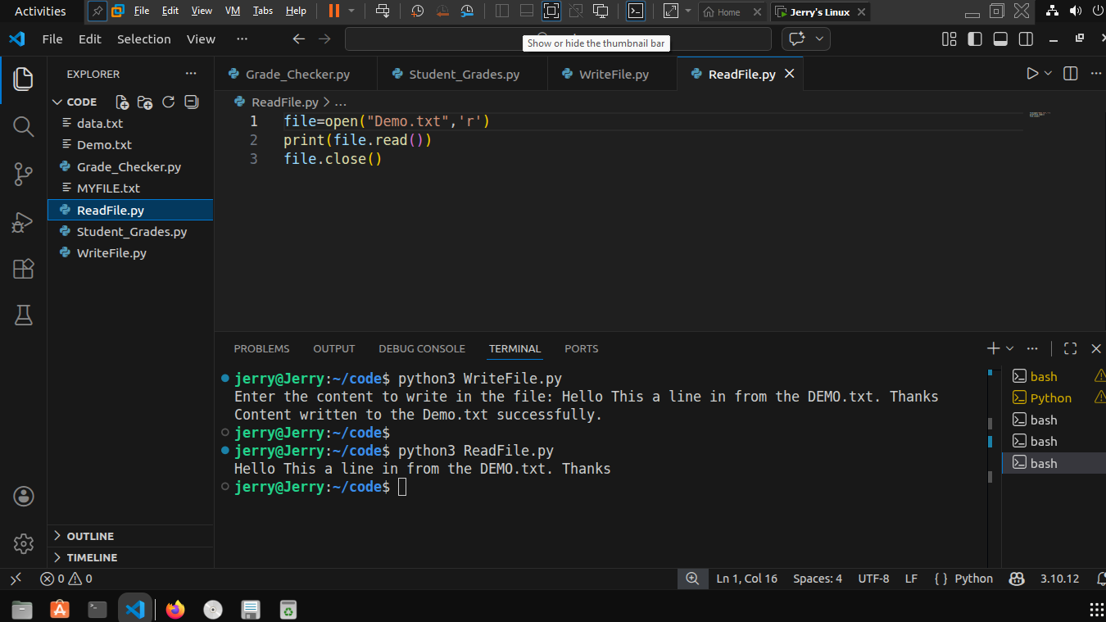
Figure 4 Read from a File

